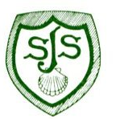
Our Values and Vision

At St James’ CE Aided Infant School we uphold and nurture our Christian ethos by encouraging the values of friendship, thankfulness, forgiveness and trust.

We will develop children’s self esteem and sense of worth by creating an environment in which they feel positive about themselves and confident to have a go and take risks in their learning.

We will make learning exciting, challenging and fun through our rich and creative curriculum, making every day different and memorable.

We will strive to meet the strengths and interests of every child by identifying their needs and matching provision.

We will create a safe, healthy and happy school community in which children and adults are cherished and valued.

We will care for the environment and the wider world and be actively involved with our community.

